## Arduino: Electronics Basics

*It seems that the first and most challenging part will be electronic engineering, which I am not an expert in. Arduino may offer a viable solution for wiring and connection. If the device's electronics would work, the device may be tested as a proof of concept. Until it is done, this may be the riskiest part of the whole feasibility of the project.*

Tutorial: https://www.youtube.com/watch?v=zJ-LqeX_fLU&t=379s

**Voltage: Water Analogy**

The pressure at the end of the hose can represent the voltage, and the water in the tank is the charge or battery. So the more water in the tank, the higher the charge and the pressure at the end of the hose.

Figure | Voltage

**Current**

The rate of flow of charge is known as current. When electrons move from a battery's negative terminal, they give rise to current. The unit of current is Amperes. The direction in which the current flows is opposite to the directions of the electrons. Therefore current is the amount of electric charge that flows when one Coulomb of charge moves past somewhere in one second. Coulomb is the measuring unit of charge. We measure current with a device called an ammeter. We can also understand the flow of current by the water analogy. The diameter of the hose acts as a resistance. The wider hose offers less resistance; thus, more current can flow through it.

Figure | Current

**AC / DC**

There are two types of current, alternative and direct. In DC, the flow of electrons stays the same direction with constant voltage. In AC, the flow of electrons changes and does not stay steady with time. The current supplied in our home socket is AC, while the batteries are DC.

Figure | AC / DC

**Resistance**

The electronic resistance of a component is the measure of the difficulty of passing an electric current through a substance. With more resistance to a circuit, less electricity will flow through. And based on this terminology, there is an electrical component called a resistor. The resistor is a device which limits the flow of a current in a circuit. For instance, we may require to use resistors in a current when using LED to prevent it from burning off.

Figure | Resistance

With the resistance with the water analogy, we can visualise how different sizes of pipes would deliver a certain amount of water flow. The wider the hosepipe is, the more water can flow through it. And the current always takes the least resistive path. Additionally, the value of a resistor is measured in Ohms. Therefore, the more the value of the resistor in Ohms, the more resistance it will offer to the circuit. Resistors are colour coded with five stripes that measure their resistance and tolerance.

Figure | Resistor Colour Chart

**Ohm's Law**

German physicist George Simon Ohm stated that the amount of electric current flowing through a metallic wire is directly proportional to the difference across it, provided the temperature remains the same. Mathematically, the voltage (V) is the product of the resistance (R) and current (I). If any of them is unknown, we can find them by the following formula.

Figure | Ohm's Law Triangle

**Ohm's Law: Circuit Example**

An elementary circuit that has:

* A 600 Ohm resistor,
* A 12 V battery,
* Figure out the current.

Figure | Calculate Current Example

**Series and Parallel Resistance**

In a series of resistors, the current of the first resistor's output flows into the second resistor and the third. Therefore, by each resistor, the voltage drop will be different. The sum of each resistor's voltage will equal the battery's voltage.

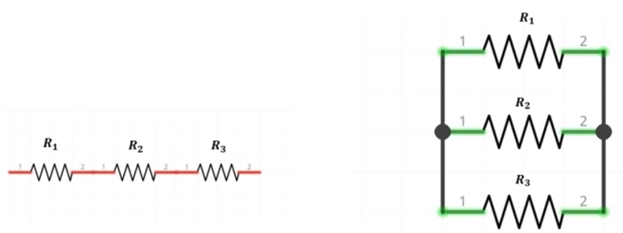

Figure | Series and Parallel Resistors

**Series Connection Example**

Figure | Calculate Series of Resistors

In a parallel circuit, the resistors are in parallel when a continous wire of negligible resistance connects all the resistors. Similarly, the ends are also connected. Since they are connected parallel, we can say that the voltages across them are equal. But unlike series resistors, the current has multiple paths to flow.

Figure | Parallel Resistors

**Parallel Resistors Example**

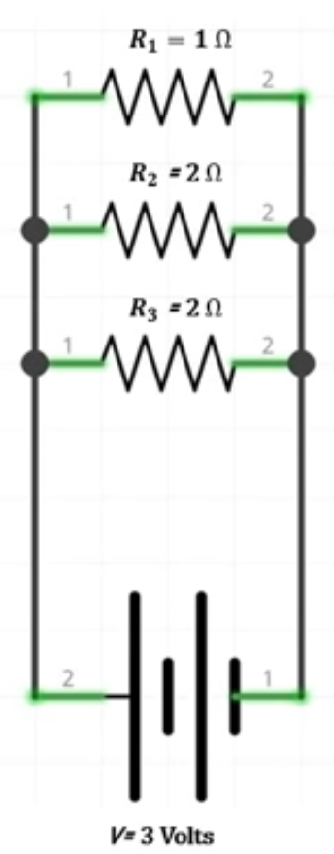

**Combinations of Series and Parallel Resistors**

We must divide the circuit into sections when resistors are mixed (parallel and series).

Figure | Mixed Resistors

**Microprocessors and Microcontrollers**

Microprocessors are known as the brain of any computer. They consist of a CPU responsible for all the computations and calculations we need. In addition, we need additional peripherals, such as RAM and ROM, to make the computer function properly.

Microcontrollers are integrated chips, basically tiny computers that are powerful enough to do many tasks, like controlling motors, pumps etc. Or send some sensor data to the internet cloud, control primary displays or even act as brains of some intermediate-level robots. The power requirement for such chips is very low; they can even run on batteries. Moreover, they have all the peripherals like memory and flash storage on the same chip. Microcontrollers are far more economical solutions than microprocessors.

**Arduino**

Arduino is a circuit which has a microcontroller on it acting as the heart of the board. The Arduino board given in a kit (Arduino Uno) uses a microcontroller ATMEGA328. There are other Arduino boards available that may be inferior or superior to Uno. Arduino's hardware and software are open-source and can be accessed and modified freely.

**The Arduino Uno Circuit Board**

Figure | Arduino Uno Circuit Board Parts

1. **Digital Pins**: Digital pins are numbered from 0 to 13, and some pins have a special symbol (~), which denotes PWM capability. Other than that, these pins take digital sensors and give digital output.
2. **Built-in LED**: The LED is connected to pin number 13 by default, so whenever PIN-13 goes high, the LED will turn on.
3. **Power LED**: If this LED is turned on, the Arduino is plugged in.
4. **ATMEGA 328 Chip**: This component controls all the main functionality of the board.
5. **Analog Pins**: This board has six analogue pins, numbered A-0 to A-5. We can connect any analogue sensor to these pins.
6. **Power Pins**: 5V and GND.
7. **Power DC Jack**: This is how you power Andruino when it is not connected to a USB port for power from 7V up to 12V.
8. **TX and RX LED**: These LEDs indicate communication between the Arduino board and the computer. RX for receive, TX for Send or Transfer.
9. **USB Jack**: Used for powering the Arduino, uploading sketches, or communicating with the computer.
10. **Reset Button**: Reloads the entire code (but does not erase any already present code).

*However, it is suggested that the Arduino Uno is not ideal for my case, and I should use Arduino Leonardo instead when dealing with multiple button presses. However, for the duration of this tutorial, I will follow through with Uno's steps to get familiar with the basic controls.*

https://www.instructables.com/Arduino-Programmable-Button-Panel-As-Keyboard/

**Setup**

Download Arduino

Set communication port:

Tools >> Port (COM 3 - default) >> COM 3

Test Arduino using built-in sketch:

File >> Examples >> 01 Basicsl >> Blink

Tools >> Board: Arduino Uno >> Arduino Uno

Port >> COM 3

Upload (+) Button

Arduino Emulator: TinkerCad

Figure | Test Arduino: Blink